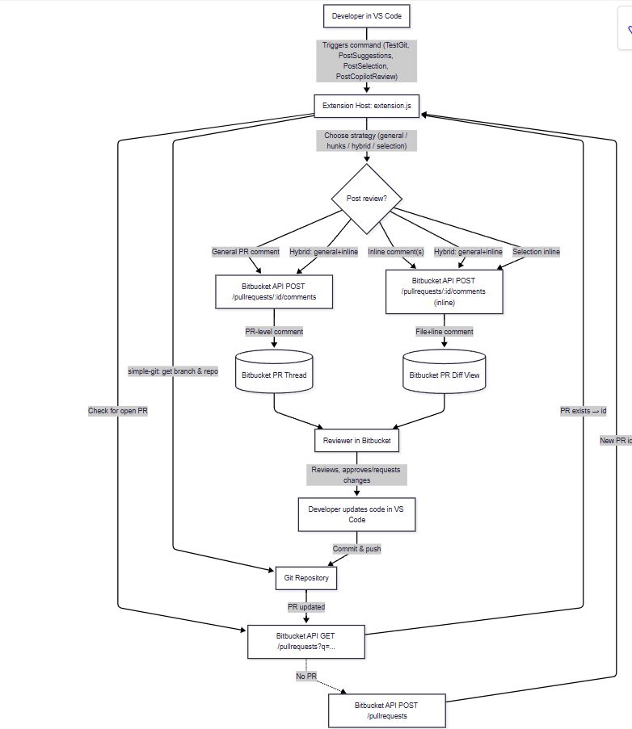
flowchart TD
A[Developer in VS Code] -->|"Triggers command (TestGit, PostSuggestions, PostSelection, PostCopilotReview)"| B[Extension Host: extension.js]

B -->|"simple-git: get branch & repo"| C[Git Repository]

B -->|"Check for open PR"| D["Bitbucket API GET /pullrequests?q=..."]
D -->|"PR exists → id"| B
D -.->|"No PR"| E["Bitbucket API POST /pullrequests"]
E -->|"New PR id"| B

%% Strategy decision
B -->|"Choose strategy (general / hunks / hybrid / selection)"| F{Post review?}

%% General comment path
F -->|"General PR comment"| G["Bitbucket API POST /pullrequests/:id/comments"]
G -->|"PR-level comment"| D1[(Bitbucket PR Thread)]

%% Inline comment path
F -->|"Inline comment(s)"| H["Bitbucket API POST /pullrequests/:id/comments (inline)"]
H -->|"File+line comment"| D2[(Bitbucket PR Diff View)]

%% Hybrid path
F -->|"Hybrid: general+inline"| G
F -->|"Hybrid: general+inline"| H

%% Selection path
F -->|"Selection inline"| H

%% Review loop
D1 & D2 --> I[Reviewer in Bitbucket]
I -->|"Reviews, approves/requests changes"| J[Developer updates code in VS Code]
J -->|"Commit & push"| C
C -->|"PR updated"| D

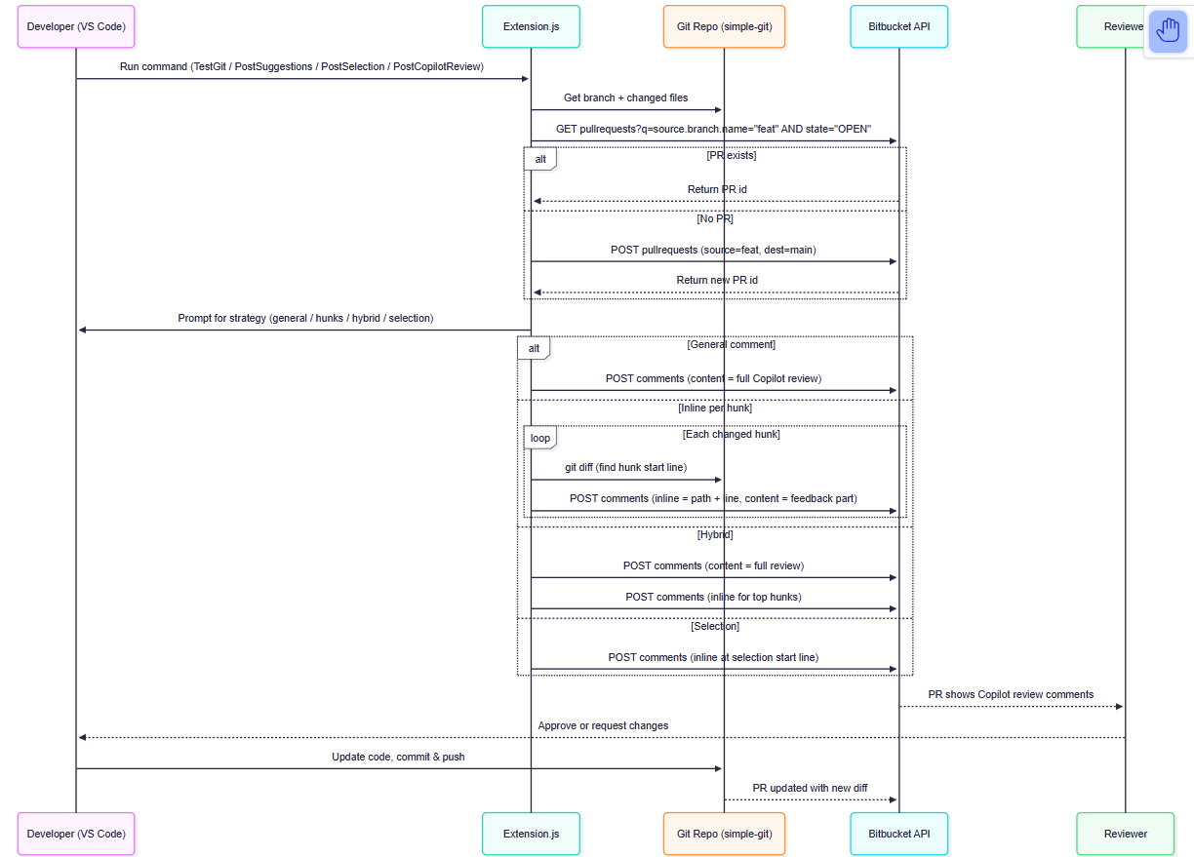

sequenceDiagram
participant Dev as Developer (VS Code)
participant Ext as Extension.js
participant Git as Git Repo (simple-git)
participant BB as Bitbucket API
participant Rev as Reviewer

Dev->>Ext: Run command (TestGit / PostSuggestions / PostSelection / PostCopilotReview)
Ext->>Git: Get branch + changed files
Ext->>BB: GET pullrequests?q=source.branch.name="feat" AND state="OPEN"
alt PR exists
BB-->>Ext: Return PR id
else No PR
Ext->>BB: POST pullrequests (source=feat, dest=main)
BB-->>Ext: Return new PR id
end

Ext->>Dev: Prompt for strategy (general / hunks / hybrid / selection)

alt General comment
Ext->>BB: POST comments (content = full Copilot review)
else Inline per hunk
loop Each changed hunk
Ext->>Git: git diff (find hunk start line)
Ext->>BB: POST comments (inline = path + line, content = feedback part)
end
else Hybrid
Ext->>BB: POST comments (content = full review)
Ext->>BB: POST comments (inline for top hunks)
else Selection
Ext->>BB: POST comments (inline at selection start line)
end

BB-->>Rev: PR shows Copilot review comments
Rev-->>Dev: Approve or request changes
Dev->>Git: Update code, commit & push
Git-->>BB: PR updated with new diff

